BOOK REGISTER AND RENTAL

# Purpose

Book register and rental module functions to manage the traffic between reader community and library and to ensure the implementation of policies related to library activities.

# Usage

To open the "Rental and Register Management" module, user must select the button "Rental and Register Management" in the tab "Main Page".

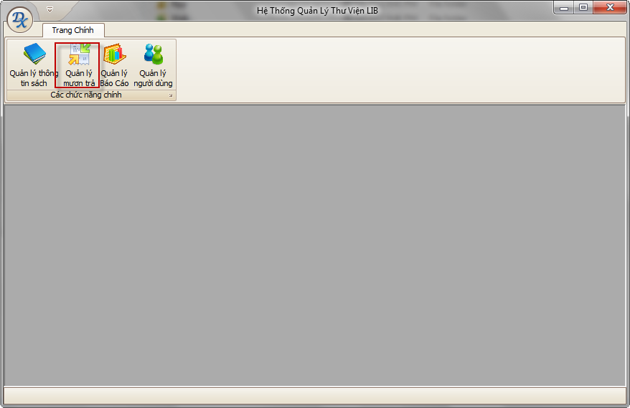

# **Main Interface**

Includes two main tabs:

* Request: Managing the borrowing requirements of the books you read.
* Borrowing to pay: Managing information about repayment of the books you read.

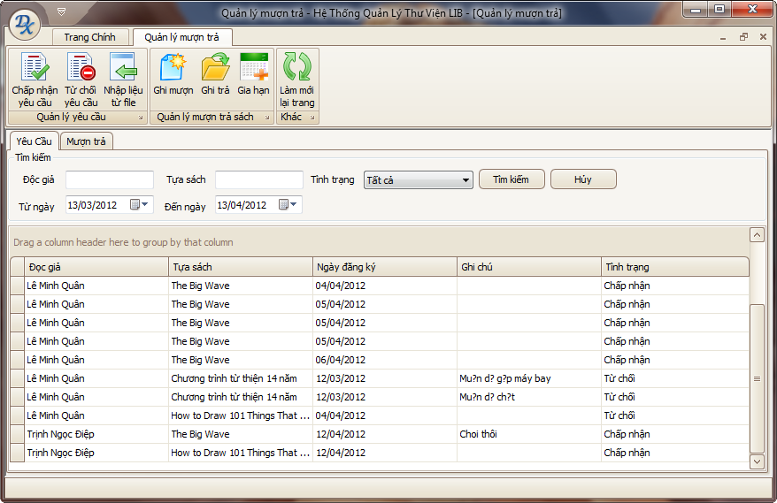

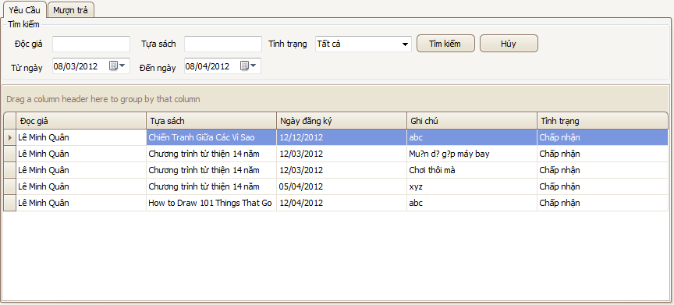

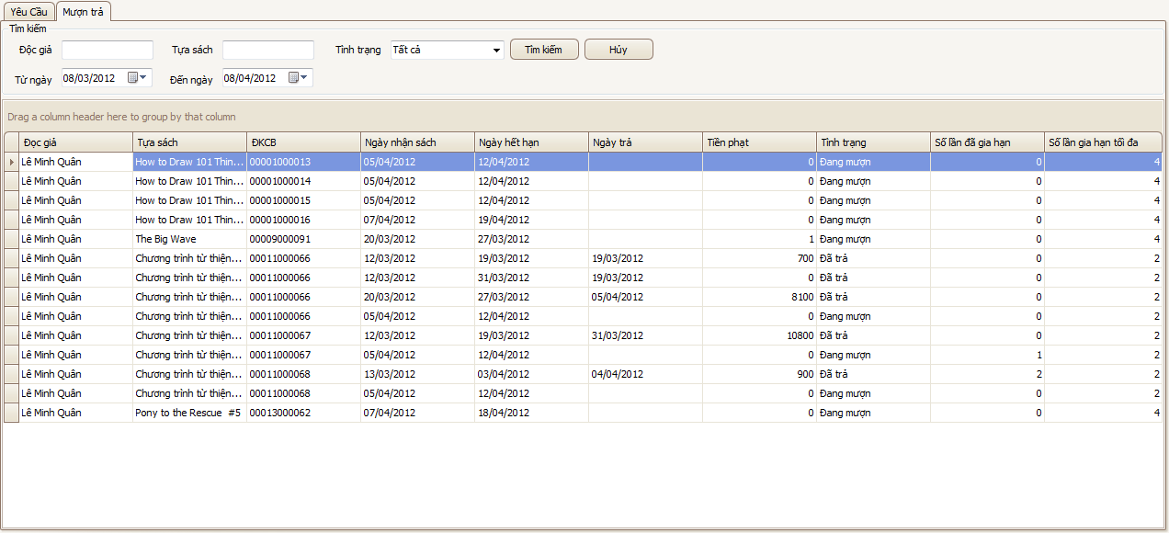

# ****Main Functions****

## Accept a request

**Purpose**

This function is used to accept a specific request is selected from the list on the screen.

**Usage**

* **Choose a request with status “New” from the list below the tab “Request”.**
* **Click button “Accept Request”.**
* **A confirm dialog will appear.  
  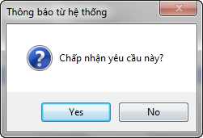**
* **Choose “Yes” to perform, “No” to cancel.**

**Effect**

After the user selects "Yes", the system will automatically perform the following actions:

* The status of this request will be revised to "Accepted"
* A rental record is added to the tab “**Rental**".
* An email is sent to inform the reader to receive the book.

## **Reject a request**

This function is used to deny a specific request selected from the list on the screen.

**Usage**

* Choose a request with the condition as "New" from the list below the tab "Request".
* Click the button "Reject Request".
* A confirmation dialog will appear. 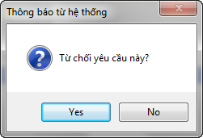
* **Choose “Yes” to perform, “No” to cancel.**

**Effect**

After the user selects "Yes", the system will automatically perform the following actions:

* The status of this request will be revised to "Denied".
* An email was sent to inform reader about the request being denied.

## **Record a rental**

**Purpose**

This function is used to record information on borrowing books or other publications in the library of the readers. It also allows the user to check the status of a borrow books you read.

**Usage**

* **Click button “Record Rental”.**
* **A dialog will appear with the following information:**

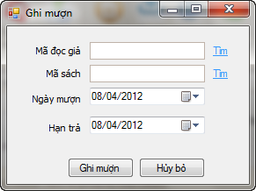

* + Reader ID: ID of the reader to borrow books. User can click on the link "Find" on the right to seek information about readers.

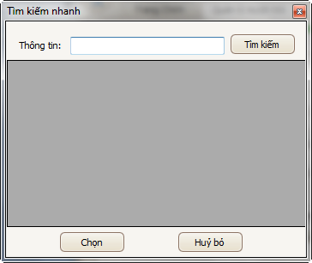

* + Book ISBN: The ISBN of the publication is being borrowed. User can click on the word "Find" on the right to search for information on publications.



* + **Borrowing Date: The date of borrowing books.**
  + **Expiry Date: The date when the rental is expired. If the reader returns books after this date, there will be a penalty.**
* **User clicks “Record Rental” to perform or “Cancel” to cancel.**

**Effect**

After users select **“Record Rental**", the system will automatically perform the following actions:

* A rental record is written to the database.
* A new line is added to the list in the tab "Rental".

## **Record a return**

**Purpose**

This function is used to record information about the payment policy. It also has the task to save the log of the borrow books you read.

**Usage**

* Select a record with the situation "is borrowed" in the tab "Borrowing to pay".
* Click the button "Remember to pay".
* A dialog box will appear

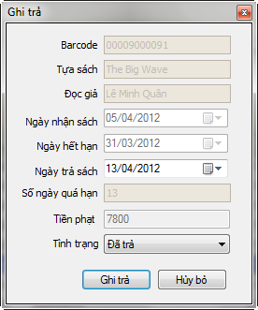

* User must enter the following information
  + **Return Date: When the reader return the book to library.** Based on the payment date and expiration policies that the system will calculate the number of days overdue and fines respectively**.**
  + **Status:** The state of the returned books. There are three types of status: Returned (the book is the same as when borrowed), Damaged (the book is damaged) and Lost. Corresponding to each state where the system will automatically calculate the cost of the fine print**.**
* Librarian collects fines (if any) from readers.
* User click on the button "Register Rental" to keep the information or button "Cancel" to cancel the operation**.**

**Effect**

After users select "Remember to pay", the system will automatically perform the following actions:

* The state of the record will be corrected corresponding to the above condition is selected.
* A rental record is written to the database.

## **Expand a rental**

**Purpose**

This function allows extended loan period for books borrowed can turn extended**.**

**Usage**

* Select a record with the status "Borrowing” in the tab "Rental".
* Click the button "Expand Rental".
* A dialog box will appear

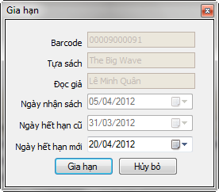

* Users must enter the following information
  + New expiration date: The specific date to be expanded to. This date must be after the old expiration date**.**
* User click on the "Expand Rental" to save the information, select "Cancel" to cancel the operation.

**Effect**

After users select "Expand Rental", the system will automatically perform the following actions:

* On the extension of the repayment record revised expiration date**.**

## **Refresh**

**Purpose**

This function is used to get the latest information from the database**.**

**Usage**

**Click button “Refresh”.**

**Effect**

After users select "Extension", the system will automatically perform the following actions:

* Information on the screen is refreshed.

## **Import data from file**

**Purpose**

This function is used to enter information on the registration of loan from an excel file in the format provided. Intended for batch registering.

**Usage**

* **Click button “Import data from file”.**
* **A dialog will appear  
  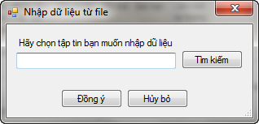**
* **User click button “Browse” to choose the excel file containing data.  
  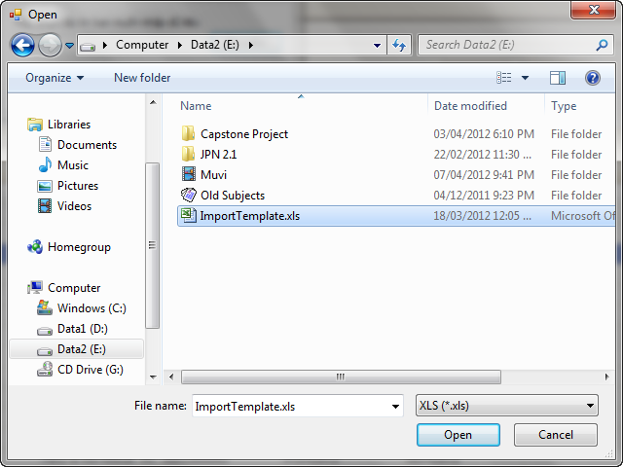**
* **Choose “OK” to perform or “Cancel” to cancel.**

**Effect**

After the user selects "Yes", the system will automatically perform the following actions:

* Data from the selected file is read out, check, and then written to the database.
* The tab "Request" refreshed with the newly input record.